**COP Assignment 1**

**Q1 - Hello World First Java Program.**

Ans - **package** day1;

**public** **class** Welcome {

**public** **static** **void** main(String[] args) {

System.out.println("Hello World Welcome to java");

}

}

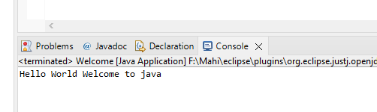**Output -**

**Q2 – Addition of Two Number in java.**

Ans - **package** day1;

**import** java.util.Scanner;

**public** **class** Additon {

**public** **static** **void** main(String[] args) {

Scanner input=**new** Scanner(System.***in***);

System.***out***.println("Please enter the value of number 1:");

**int** num1 = input.nextInt();

System.***out***.println("Please Enter the value of number 2:");

**int** num2 = input.nextInt();

**int** ans= num1+num2;

System.***out***.println("Addition of Entered Number is = "+ ans);

input.close();

}

}

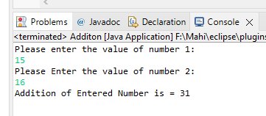Output -

**Q3 – Swap two number in java.**

Ans - **package** day1;

**import** java.util.Scanner;

**public** **class** SwapTwoNumber {

**public** **static** **void** main(String[] args) {

Scanner in=**new** Scanner(System.***in***);

System.***out***.println("Please Enter the Number 1:");

**int** num1=in.nextInt();

System.***out***.println("Please Enter the Number 2:");

**int** num2 =in.nextInt();

System.***out***.println("Before Swapping Numbe are num1:"+num1+ " and num2:"+num2);

num1=num1+num2;

num2=num1-num2;

num1=num1-num2;

System.***out***.println("After Swapping Number are num1:"+num1+ " and num2:"+num2);

in.close();

}

}

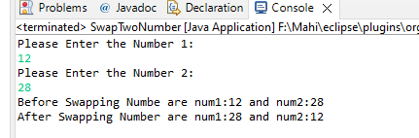OutPut -

**Q4 – check even or odd in java.**

**Ans** - **package** day1;

**import** java.util.Scanner;

**public** **class** EvenOdd {

**public** **static** **void** main(String[] args) {

System.***out***.println("Please Enter the number want to check Even or odd:");

Scanner in = **new** Scanner(System.***in***);

**int** num = in.nextInt();

**if** (num % 2 == 0) {

System.***out***.println("Entered Number is Even");

} **else**

System.***out***.println("Entered Numbe is odd");

in.close();

}

}

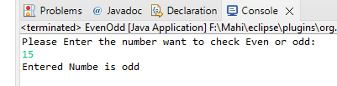Output -

**Q5 – Divisible by 5 and 7 in java.**

Ans - **package** day1;

**import** java.util.Scanner;

**public** **class** Divisibilityby5and7 {

**public** **static** **void** main(String[] args) {

Scanner in = **new** Scanner(System.***in***);

System.***out***.println("Enter the number to check divisible or not by 5 and 7 :");

**int** num = in.nextInt();

**if** (num % 5 == 0 && num % 7 == 0) {

System.***out***.println("Entered number is divisible by 5 and 7 both");

} **else**

System.***out***.println("Entered number is not divisible by 5 and 7");

in.close();

}

}

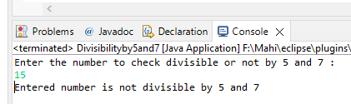Output

**Q6 – Calculate Income tax using basic salary.**

Ans - **package** day1;

**import** java.util.Scanner;

**public** **class** SalaryOfEmployee {

**public** **static** **void** main(String[] args) {

Scanner in = **new** Scanner(System.***in***);

System.***out***.println("Please Enter the basic salary of employee:");

**int** basicSalary=in.nextInt();

**int** netSalary=0;

**if**(basicSalary<150000) {

netSalary=basicSalary+0;

}

**else** **if**(basicSalary > 150000 && basicSalary < 300000) {

netSalary=(**int**) (basicSalary-0.2*basicSalary);

}

**else**

netSalary=(**int**) (basicSalary-basicSalary*0.3);

System.***out***.println("Net Salary of Employee is :"+ netSalary);

in.close();

}

}

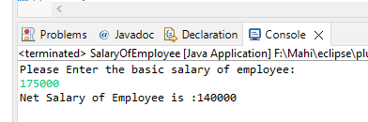 Output -

**Q7 – Check vowel or not Character from user.**

Ans - **package** day1;

**import** java.util.Scanner;

**public** **class** CheckForVowel {

**public** **static** **void** main(String[] args) {

Scanner in = **new** Scanner(System.***in***);

System.***out***.println("Please Enter the Character :");

**char** ch =in.next().charAt(0);

**switch**(ch) {

**case** 'a':

**case** 'e':

**case** 'i':

**case** 'o':

**case** 'u':

**case** 'A':

**case** 'E':

**case** 'I':

**case** 'O':

**case** 'U':

System.***out***.println("Enter character is Vowel");

**break**;

**default**:

System.***out***.println("Enter character is consonant");

}

in.close();

}

}

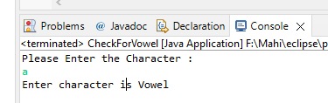Output -

**Q8 – Angle is valid or not.**

Ans - **package** day1;

**import** java.util.Scanner;

**public** **class** AngleIsValid {

**public** **static** **void** main(String[] args) {

Scanner in = **new** Scanner(System.***in***);

System.***out***.println("Enter the all Angle of Triangle :");

**int** a1 = in.nextInt();

**int** a2 = in.nextInt();

**int** a3 = in.nextInt();

**int** angle = a1 + a2 + a3;

**if** (angle == 180) {

System.***out***.println("This is a valid Triangle");

} **else**

System.***out***.println("This is not valid Triangle");

in.close();

}

}

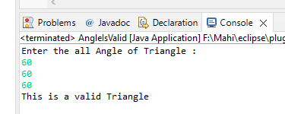Output –

**Q9 – Factorial of Input number from user.**

Ans - **package** day1;

**import** java.util.Scanner;

**public** **class** FactorialOfNumber {

**public** **static** **void** main(String[] args) {

Scanner in = **new** Scanner(System.***in***);

System.***out***.println("Enter the number want to print factorial:");

**int** num = in.nextInt();

**int** fact = 1;

**for** (**int** i = 1; i < num; i++) {

fact = fact + fact * i;

}

System.***out***.println("Factorial is:"+fact);

in.close();

}

}

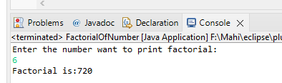Output

**Q10 - Power m raise to n from user.**

Ans - **package** day1;

**import** java.util.Scanner;

**public** **class** PowerOfNumber {

**public** **static** **void** main(String[] args) {

Scanner in = **new** Scanner(System.***in***);

System.***out***.println("Enter the Number M=\n");

**int** num = in.nextInt();

System.***out***.println("Enter the Power N=\n");

**int** n = in.nextInt();

**int** power = 1;

**for** (**int** i = 0; i < n; i++) {

power =power*num;

}

System.***out***.println(num + " Raised to power " + n + " is =" + power);

in.close();

}

}

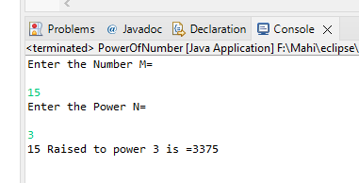Output –

**Q11 – Check Number prime or not.**

Ans - **package** day1;

**import** java.util.Scanner;

**public** **class** PrimeNumberOrNot {

**public** **static** **void** main(String[] args) {

Scanner in= **new** Scanner(System.***in***);

System.***out***.println("Enter the number to check prime or not:");

**int** num=in.nextInt();

**int** count=0;

**for**(**int** i=1;i<=num;i++) {

**if**(num%i==0) {

count++;

}

}

**if**(count==2) {

System.***out***.println("This is Prime Number ");

}

**else**

{

System.***out***.println("This is not Prime Number ");

}

in.close();

}

}

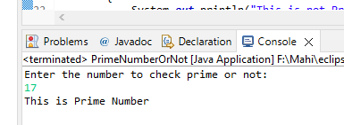Output -

**Q12 – Sum of series 1+2+3…..n**

Ans - **package** day1;

**import** java.util.Scanner;

**public** **class** SumOfSeries {

**public** **static** **void** main(String[] args) {

Scanner in= **new** Scanner(System.***in***);

System.***out***.println("Enter the number till want sum of all number :");

**int** num=in.nextInt();

**int** ans =0;

**for**(**int** i=0;i<=num;i++) {

ans+=i;

}

System.***out***.println("Sum of all number is :"+ans);

in.close();

}

}

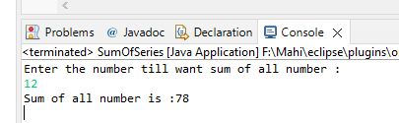Output –

**Q13 – Palindrome or not.**

Ans - **package** day1;

**import** java.util.Scanner;

**public** **class** PalindromeNumber {

**public** **static** **void** main(String[] args) {

Scanner in = **new** Scanner(System.***in***);

System.***out***.println("Enter the number to check Palindrome or not:");

**int** num = in.nextInt();

**int** original = num;

**int** rev = 0, rem;

**while** (num != 0) {

rem = num % 10;

rev = rev * 10 + rem;

num = num / 10;

}

**if** (rev == original) {

System.***out***.println("This is Palindrome Number");

} **else** {

System.***out***.println("This is not Palindrome");

in.close();

}

}

}

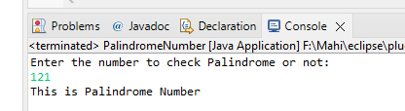Output -

**Q14 – Sum of Odd and Even up to n.**

Ans - **package** day1;

**import** java.util.Scanner;

**public** **class** SumOfEvenAndOddNumber {

**public** **static** **void** main(String[] args) {

Scanner in = **new** Scanner(System.in);

System.out.println("Enter the Number for sum of all even and odd:");

**int** num = in.nextInt();

**int** sumofeven = 0;

**int** sumofodd = 0;

**for** (**int** i = 1; i <= num; i++) {

**if** (num % i == 0) {

sumofeven = sumofeven + i;

} **else** {

sumofodd += i;

}

}

System.out.println("The sum of all Even number :" + sumofeven);

System.out.println("The sum of all odd number :" + sumofodd);

in.close();

}

}

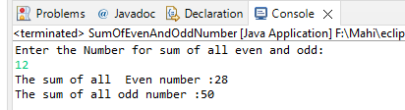Output –

**Q15 – Reverse of number.**

Ans - **package** day1;

**import** java.util.Scanner;

**public** **class** ReverseOfNumber {

**public** **static** **void** main(String[] args) {

Scanner in = **new** Scanner(System.***in***);

System.***out***.println("Enter the number for Reverse of Number :");

**int** num = in.nextInt();

**int** rem, rev = 0;

**while** (num > 0) {

rem = num % 10;

rev = rev * 10 + rem;

num = num / 10;

}

System.***out***.println("Reverse of given number is :" + rev);

in.close();

}

}

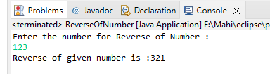Output –

**Q16 – Printing all prime Number up to n.**

Ans - **package** day1;

**import** java.util.Scanner;

**public** **class** PrimeNumerUptoN {

**public** **static** **void** main(String[] args) {

Scanner in = **new** Scanner(System.***in***);

System.***out***.println("Enter the number to print all prime number:");

**int** maxNumber = in.nextInt();

**for** (**int** num = 2; num <= maxNumber; num++) {

**boolean** isPrime = **true**;

**for** (**int** i = 2; i <= num / 2; i++) {

**if** (num % i == 0) {

isPrime = **false**;

**break**;

}

}

**if** (isPrime == **true**)

System.***out***.println(num);

in.close();

}

}

}

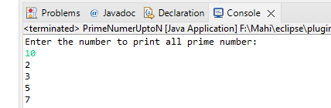Output –

**Q17 – Number Armstrong or not.**

Ans - **package** day1;

**import** java.util.Scanner;

**public** **class** ArmstrongNumber {

**public** **static** **void** main(String[] args) {

Scanner in = **new** Scanner(System.***in***);

System.***out***.println("Enter the number to check Armstrong or not :");

**int** number = in.nextInt();

**int** originalNumber, remainder, result = 0;

originalNumber = number;

**while** (originalNumber != 0) {

remainder = originalNumber % 10;

result += Math.*pow*(remainder, 3);

originalNumber /= 10;

}

**if** (result == number)

System.***out***.println(number + " is an Armstrong number.");

**else**

System.***out***.println(number + " is not an Armstrong number.");

in.close();

}

}

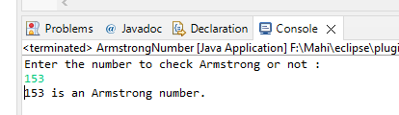

Output –

**Q18 – Maximum in three number.**

Ans - **package** day1;

**import** java.util.Scanner;

**public** **class** MaximumOfThreeNumber {

**public** **static** **void** main(String[] args) {

Scanner in = **new** Scanner(System.***in***);

System.***out***.println("Enter the Three number one by one:");

**int** num1 = in.nextInt();

**int** num2 = in.nextInt();

**int** num3 = in.nextInt();

**if** (num1 > num2 && num1 > num3) {

System.***out***.println("Number 1 is Maximum Number among three");

} **else** **if** (num2 > num1 && num2 > num3) {

System.***out***.println("Number 2 is Maximum Number among three");

} **else** **if** (num3 > num1 && num3 > num2) {

System.***out***.println("Number 3 is Maximum Number among three");

}in.close();

}

}

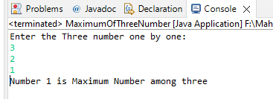Output –

**Q19 – Menu driven for pizza shop.**

Ans - **package** day1;

**import** java.util.Scanner;

**public** **class** MenuDrivenPizzaShop {

**public** **static** **void** main(String[] args) {

Scanner in = **new** Scanner(System.***in***);

System.***out***.println("----Menu----");

System.***out***.println("1:Plane Pizza(100) 2:Cheeze Pizza(120) 3:Margerita(150) 4:Exit");

**int** choice, qty, total = 0;

**do** {

System.***out***.println("Enter choice");

choice = in.nextInt();

**switch** (choice) {

**case** 1:

System.***out***.println("Enter the Qauntity of Pizza:");

qty = in.nextInt();

total = qty * 100;

**break**;

**case** 2:

System.***out***.println("Enter the Qauntity of Pizza:");

qty = in.nextInt();

total = total + qty * 120;

**break**;

**case** 3:

System.***out***.println("Enter the Qauntity of Pizza:");

qty = in.nextInt();

total = total + qty * 150;

**break**;

**case** 4:

System.***out***.println("Total Bill:" + total);

**break**;

**default**:

System.***out***.println("Invalid Input");

}

} **while** (choice != 4);

in.close();

}

}

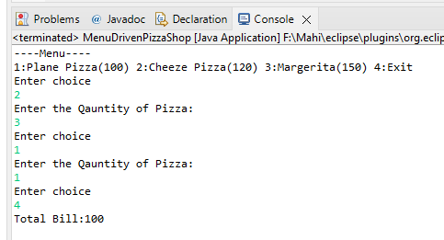Output –

**Q20 – Convert digit into words.**

Ans - **package** day1;

**import** java.util.Scanner;

**public** **class** DisplayInWords {

**public** **static** **void** main(String[] args) {

Scanner in = **new** Scanner(System.***in***);

System.***out***.println("Enter the Number to display in words:");

**int** num = in.nextInt();

**switch** (num) {

**case** 1:

System.***out***.println("ONE");

**break**;

**case** 2:

System.***out***.println("TWO");

**break**;

**case** 3:

System.***out***.println("THREEE");

**break**;

**case** 4:

System.***out***.println("FOUR");

**break**;

**case** 5:

System.***out***.println("FIVE");

**break**;

**case** 6:

System.***out***.println("SIX");

**break**;

**case** 7:

System.***out***.println("SEVEN");

**break**;

**case** 8:

System.***out***.println("EIGHT");

**break**;

**case** 9:

System.***out***.println("NINE");

**break**;

**default**:

System.***out***.println("Invalid Entry , Please Enter Valid Entry");

in.close();

}

}

}

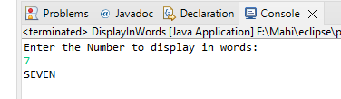Output –

**Q21 - Menu driven operation on operators.**

Ans – **package** day1;

**import** java.util.Scanner;

**public** **class** MenuDrivenOperation {

**public** **static** **void** main(String[] args) {

Scanner in = **new** Scanner(System.***in***);

**int** ans, num1, num2, choice;

**do** {

System.***out***.println("Enter the choice that operation want to perform");

System.***out***.println("1:Addition 2:Subtraction 3:Multiplication 4:Division 5:Exit");

choice = in.nextInt();

**switch** (choice) {

**case** 1:

System.***out***.println("Please Enter Numbers :");

num1 = in.nextInt();

num2 = in.nextInt();

ans = num1 + num2;

System.***out***.println("Addition of two Number is = " + ans);

**break**;

**case** 2:

System.***out***.println("Please Enter Numbers :");

num1 = in.nextInt();

num2 = in.nextInt();

ans = num1 - num2;

System.***out***.println("Subtraction of two number is = " + ans);

**break**;

**case** 3:

System.***out***.println("Please Enter Numbers :");

num1 = in.nextInt();

num2 = in.nextInt();

ans = num1 * num2;

System.***out***.println("Multiplication of two number is = " + ans);

**break**;

**case** 4:

System.***out***.println("Please Enter Numbers :");

num1 = in.nextInt();

num2 = in.nextInt();

ans = num1 / num2;

System.***out***.println("Division of Two Number is = " + ans);

**break**;

**case** 5:

System.***out***.println("-----Program End------");

**break**;

**default**:

System.***out***.println("INVALID CHOICE");

}

} **while** (choice != 5);

in.close();

}

}

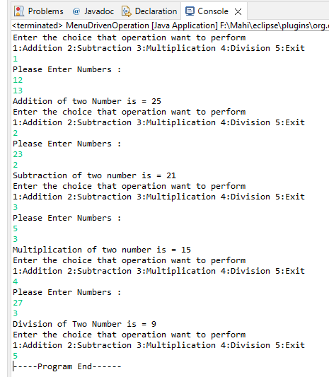Output

**COP Assignment 2**

**Q1 - Java program to print the following pattern on the console**

Ans - **package** day2and3;

**public** **class** Pattern {

**public** **static** **void** main(String[] args) {

**for** (**int** i = 0; i < 5; i++) {

**for** (**int** j = 0; j <= i; j++) {

System.out.print(" *");

}

System.out.println();

}

}

}

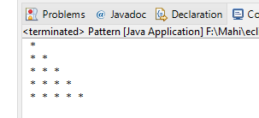

Output –

**Q2 - Write a program which will accept student information like rollno,name,5 subject marks.calculate total and percentage.calculate grade.per>75 grade :A per<74and>60 :B per<59 :C**

**Ans - package** day2and3;

**import** java.util.Scanner;

**public** **class** StudentInfo {

**public** **static** **void** main(String[] args) {

Scanner in=**new** Scanner(System.***in***);

System.***out***.println("Enter the Information of student - ");

System.***out***.println("Enter the Roll Number of student : ");

**int** rollNo=in.nextInt();

System.***out***.println("Enter Name of student :");

String name= in.next();

System.***out***.println("Enter the marks of student in 5 subject out of 100 mark:");

**int** m1=in.nextInt();

**int** m2=in.nextInt();

**int** m3=in.nextInt();

**int** m4=in.nextInt();

**int** m5=in.nextInt();

**int** total=m1+m2+m3+m4+m5;

**float** perc=total/5;

**if**(perc>75) {

System.***out***.println("Name : "+ name + "\nRoll Number : "+rollNo);

System.***out***.println("Percentage : " +perc +"\nGrade : A");

}

**else** **if**(perc>60&&perc<74) {

System.***out***.println("Name : "+name + "\nRoll Number : "+rollNo);

System.***out***.println("Percentage : " +perc +"\nGrade : B" );

}**else** {

System.***out***.println("Name : "+name+ "\nRoll Number : "+rollNo);

System.***out***.println("Percentage :"+perc + "Grade : c");

in.close();

}

}

}

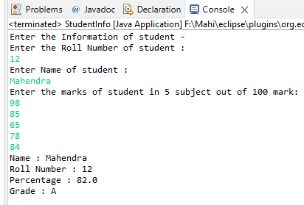Output –

**Q3 - Write a Java program to find the maximum and minimum value of an array.**

Ans - **package** day2and3;

**import** java.util.Scanner;

**public** **class** MaxandMininArray {

**public** **static** **void** main(String[] args) {

Scanner in = **new** Scanner(System.***in***);

System.***out***.println("How many Element you want to enter in Array: ");

**int** No = in.nextInt();

**int**[] arr = **new** **int**[No];

System.***out***.println("Enter the element of Array");

**for** (**int** i = 0; i < No; i++) {

arr[i] = in.nextInt();

}

**int** max = arr[0], min = arr[0];

**for** (**int** i = 0; i < No; i++) {

**if** (max < arr[i]) {

max = arr[i];

}

**if** (min > arr[i]) {

min = arr[i];

}

}

System.***out***.println("Maximum =" + max + "\nMinimum = " + min);

in.close();

}

}

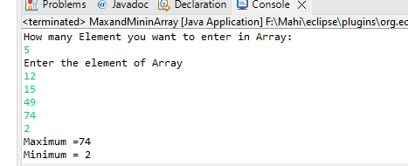Output –

**Q4 - Write a menu driven program for stationary shop. Items are 1:Pen 2:Pencil 3:NoteBook 4:Bottle 5:ColorBox.1 pen cost is 10Rs,Pencil is 5 rs. NoteBook is 20 rs Bottle is 30 rs and ColorBox is at 50 Rs. Calculate Total of all purchesed items.**

Ans - **package** day2and3;

**import** java.util.Scanner;

**public** **class** StationaryShop {

**public** **static** **void** main(String[] args) {

Scanner in = **new** Scanner(System.***in***);

System.***out***.println("----Menu----");

System.***out***.println("1:Pen(10) 2:Pencil(5) 3:NoteBook(20) 4:Bottle(30) 5:ColorBox(50) 6:Exit");

**int** qty, choice, total = 0;

**do** {

System.***out***.println("Enter Choice ");

choice = in.nextInt();

**switch** (choice) {

**case** 1:

System.***out***.println("Enter Qty of Pens : ");

qty = in.nextInt();

total = total + qty * 10;

**break**;

**case** 2:

System.***out***.println("Enter the Qty of Pencils :");

qty = in.nextInt();

total = total + qty * 5;

**break**;

**case** 3:

System.***out***.println("Enter the Qty of NoteBooks :");

qty = in.nextInt();

total = total + qty * 20;

**break**;

**case** 4:

System.***out***.println("Enter the Qty of Bottles : ");

qty = in.nextInt();

total = total + qty * 30;

**break**;

**case** 5:

System.***out***.println("Enter the Qty of Colorbox : ");

qty = in.nextInt();

total = total + qty * 50;

**break**;

**case** 6:

System.***out***.println("Total bill : " + total);

}

} **while** (choice != 6);

in.close();

}

}

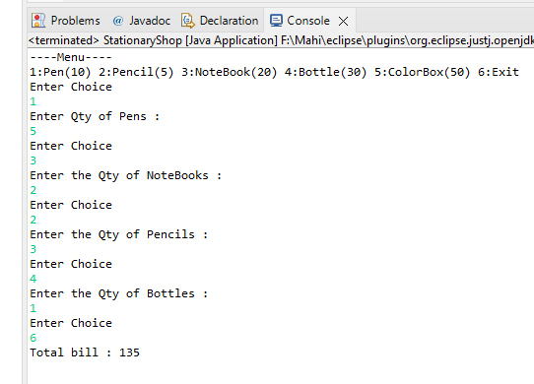Output –

**Q5 - Write a Java program to accept 2D aaray elements.Display all elements.**

Ans - **package** day2and3;

**import** java.util.Scanner;

**public** **class** Array2DAccept {

**public** **static** **void** main(String[] args) {

Scanner in = **new** Scanner(System.***in***);

System.***out***.println("Enter the number of rows");

**int** row = in.nextInt();

System.***out***.println("Enter the number of columns");

**int** col = in.nextInt();

**int**[][] arr = **new** **int**[row][col];

System.***out***.println("Enter Elements of an Array");

**for** (**int** i = 0; i < row; i++) {

**for** (**int** j = 0; j < col; j++) {

arr[i][j] = in.nextInt();

}

}

System.***out***.println("Elements of array are:");

**for** (**int** i = 0; i < row; i++) {

**for** (**int** j = 0; j < col; j++) {

System.***out***.print(arr[i][j] + " ");

}

System.***out***.println();

in.close();

}

}

}

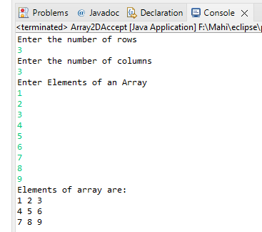Output -

**Q6 - Write a java program to make the addition of two 2D array And store result in Third array.**

Ans - **package** day2and3;

**import** java.util.Scanner;

**public** **class** Addition2DArray {

**public** **static** **void** main(String[] args) {

Scanner in = **new** Scanner(System.***in***);

System.***out***.println("Enter the number of row for 1st 2D Array: ");

**int** row1 = in.nextInt();

System.***out***.println("Enter the number of column for 1st 2D Array: ");

**int** col1 = in.nextInt();

System.***out***.println("Enter the number of row for 2nd 2D Array: ");

**int** row2 = in.nextInt();

System.***out***.println("Enter the number of column for 2nd 2D Array: ");

**int** col2 = in.nextInt();

**int**[][] arr = **new** **int**[row1][col1];

**int**[][] arr2 = **new** **int**[row2][col2];

**int**[][] arr3 = **new** **int**[row1][col1];

System.***out***.println("Enter the elements of an First Array: ");

**for** (**int** i = 0; i < row1; i++) {

**for** (**int** j = 0; j < col1; j++) {

arr[i][j] = in.nextInt();

}

}

System.***out***.println("Enter the elements of an Second Array: ");

**for** (**int** i = 0; i < row2; i++) {

**for** (**int** j = 0; j < col2; j++) {

arr2[i][j] = in.nextInt();

}

}

**for** (**int** i = 0; i < row1; i++) {

**for** (**int** j = 0; j < col1; j++) {

arr3[i][j] = arr[i][j] + arr2[i][j];

}

}

System.***out***.println("Sum of two 2D Array :");

**for** (**int** i = 0; i < row1; i++) {

**for** (**int** j = 0; j < col1; j++) {

System.***out***.print(arr3[i][j]+" ");

}

System.***out***.println();

in.close();

}

}

}

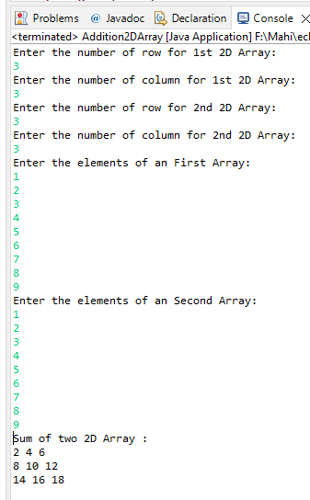Output –

**Q7 - Write a java program to convert char array into String.**

**Ans - package** day2and3;

**import** java.util.Scanner;

**public** **class** CharacterToString {

**public** **static** **void** main(String[] args) {

Scanner in=**new** Scanner(System.***in***);

**char** ch[]= {'M','A','H','E','N','D','R','A'};

String str = **new** String(ch);

System.***out***.println(str);

in.close();

}

}

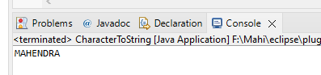

Output –

**Q8 - Write a program to accept array of string. Display all elements in uppercase.**

Ans - **package** day2and3;

**import** java.util.Scanner;

**public** **class** ArrayofString {

**public** **static** **void** main(String[] args) {

Scanner in = **new** Scanner(System.***in***);

System.***out***.println("Enter the String element in Array");

String[] arr = **new** String[5];

**for** (**int** i = 0; i < arr.length; i++) {

arr[i] = in.next();

}

**for** (**int** i = 0; i < arr.length; i++) {

System.***out***.println((arr[i]));

}

in.close();

}

}

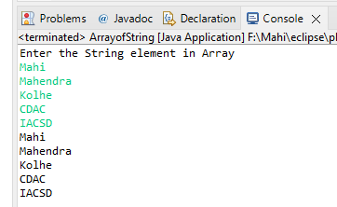Output –

**Q9 - Create Menu driven program for array operations.1:Read Array 2:Print Array 3:Search element in array 4:Reverse Array 5:Even number from array6:sum of array element**

Ans - **package** day2and3;

**import** java.util.Scanner;

**public** **class** ArrayOperation {

**public** **static** **void** main(String[] args) {

Scanner in = **new** Scanner(System.***in***);

System.***out***.println("Enter the number of Element you want in Array :");

**int** num = in.nextInt();

**int**[] arr = **new** **int**[num];

System.***out***.println("Enter the Array Element : ");

**for** (**int** i = 0; i < arr.length; i++) {

arr[i] = in.nextInt();

}

System.***out***.println(

"1:Print Array 2:Seach Element 3: Reverse Array 4:Even Number from Array 5:sum of Array Element 6:Exit");

**int** operation;

**do** {

System.***out***.println("\nEnter operation want to perform on array:");

operation = in.nextInt();

**switch** (operation) {

**case** 1:

System.***out***.println("Element of Array are:");

**for** (**int** i = 0; i < arr.length; i++) {

System.***out***.print(arr[i] + " ");

}

**break**;

**case** 2:

System.***out***.println("Enter the element want to search:");

**int** target = in.nextInt();

**int** count = 0;

**int** index = 0;

**for** (**int** i = 0; i < arr.length; i++) {

**if** (target == arr[i]) {

count++;

index = i;

}

}

**if** (count == 1) {

System.***out***.println("Element found at index:" + index);

} **else** {

System.***out***.println("Element not found in Array");

}

**break**;

**case** 3:

System.***out***.println("Reverse Array:");

**for** (**int** i = arr.length - 1; i >= 0; i--) {

System.***out***.print(arr[i] + " ");

}

**break**;

**case** 4:

System.***out***.println("Even Numbers in Array are:");

**for** (**int** i = 0; i < arr.length; i++) {

**if** (arr[i] % 2 == 0)

System.***out***.print(arr[i] + " ");

}

**break**;

**case** 5:

**int** sum = 0;

**for** (**int** i = 0; i < arr.length; i++) {

sum = sum + arr[i];

}

System.***out***.println("Sum of Array Element is :" + sum);

**break**;

**case** 6:

System.***out***.println("PROGRAM END");

**break**;

**default**:

System.***out***.println("Invalid Entry");

}

} **while** (operation != 6);

in.close();

}

}

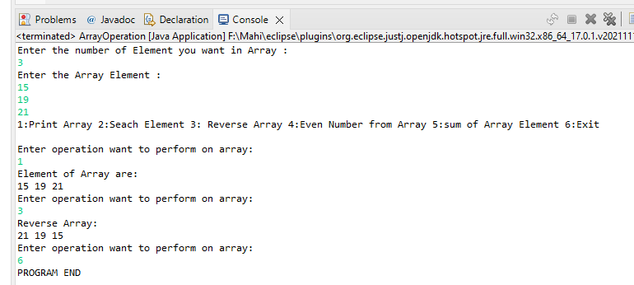Output –

**Q10 - read two int array...and store both in third array and display third array**

Ans - **package** day2and3;

**public** **class** ConcatenationArray {

**public** **static** **void** main(String[] args) {

**int**[] arr1 = { 1, 2, 3 };

**int**[] arr2 = { 5, 6, 7, 8, 9 };

**int**[] result = **new** **int**[arr1.length + arr2.length];

**int** count = 0;

**for** (**int** i : arr1) {

result[count] = i;

count++;

}

**for** (**int** i : arr2) {

result[count] = i;

count++;

}

System.***out***.print("Array Element are :");

**for** (**int** i = 0; i < result.length; i++) {

System.***out***.print(result[i]+" ");

}

}

}

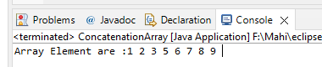Output –

**Q11 - Create application for method overloading.**

Ans - **package** day2and3;

**import** java.util.Scanner;

**public** **class** OverLoading {

**public** **static** **void** main(String[] args) {

Scanner in = **new** Scanner(System.***in***);

System.***out***.println("Enter the number to perform addition:");

*add*(in.nextInt(), in.nextInt());

*add*(in.nextInt(), in.nextInt(), in.nextInt());

*add*(in.nextInt(), in.nextFloat());

*add*(in.nextFloat(), in.nextFloat());

in.close();}

**public** **static** **void** add(**int** a, **int** b) {

System.***out***.println("Additon of two numbers is:" + (a + b));}

**public** **static** **void** add(**int** a, **int** b, **int** c) {

System.***out***.println(("Addition of three numbers is:" + (a + b + c)));}

**public** **static** **void** add(**int** a, **float** b) {

System.***out***.println("Addition of two number is : " + ((**float**) a + b));}

**public** **static** **void** add(**float** a, **float** b) {

System.***out***.println("Addition of two number is :" + (a + b));}}

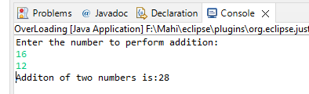Output

**COP Assignment 3**

**Q1 - Write a program to create student class with data members rollno, marks1,mark2,mark3. Accept data (acceptInfo()) and display using display member function. Also display total,percentage and grade.**

Ans - **package** day4and5and6;

**import** java.util.Scanner;

**public** **class** StudentInfo {

**public** **static** **void** main(String[] args) {

Scanner in = **new** Scanner(System.in);

**int** total;

**float** perc;

System.out.println("Enter the roll number and Marks of Student:");

**int** rollNo = in.nextInt(), mark1 = in.nextInt(), mark2 = in.nextInt(), mark3 = in.nextInt();

total = mark1 + mark2 + mark3;

perc = total / 3;

System.out.println("Roll Number:" + rollNo);

display(total, perc);

in.close();

}

**public** **static** **void** display(**int** totalM, **float** perC) {

System.out.println("Total Marks of Student :" + totalM + "Percentage of student is :" + perC);

}

}

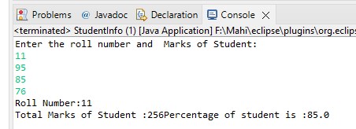Output

**Q2 - Create a class Person with data members as name, age, city. Write getters and setters for all the data members. Also add the display function. Create Default and Parameterized constructors. Create the object of this class in main method and invoke all the methods in that class.**

Ans - **package** day4and5and6;

**public** **class** Person {

**private** String name;

**private** **int** age;

**private** String city;

**public** Person() {

name="Ram";

age=21;

city="Pune";

}

**public** Person(String name,**int** age , String city) {

**this**.name=name;

**this**.age=age;

**this**.city=city;

}

**public** **void** display() {

System.***out***.println("Name: "+name+"\nAge: "+age+"\nCity: "+city);

}

**public** **void** setter(String name ,**int** age,String city) {

**this**.name=name;

**this**.age=age;

**this**.city=city;

}

**public** String getName() {

**return** name;

}

**public** **int** getAge() {

**return** age;

}

**public** String getCity() {

**return** city;

}

}

**package** day4and5and6;

**public** **class** TestPerson {

**public** **static** **void** main(String[] args) {

Person P1 = **new** Person();

P1.display();

Person P2=**new** Person("mahi",25,"Pune");

//P2.display();

**int** a=P2.getAge();

System.***out***.println("Age:"+a);

P2.setter("MK", 26, "MUMBAi");

P2.display();

}

}

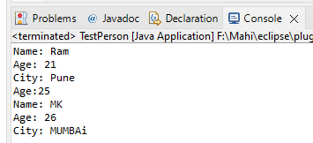Output –

**Q3 - Create a class Date with data members as dd, mm, yy. Write getters and setters for all the data members. Also add the display function. Create Default and Parameterized constructors. Create the object of this class in main method and invoke all the methods in that class.**

Ans – **package** day4and5and6;

**public** **class** Date {

**private** **int** dd;

**private** **int** mm;

**private** **int** yy;

**public** Date()

{

dd=31;

mm=12;

yy=96;

}

**public** Date(**int** dd,**int** mm,**int** yy)

{

**this**.dd=dd;

**this**.mm=mm;

**this**.yy=yy;

}

**public** **void** display()

{

System.out.println("Day="+dd +" Month ="+mm+" year= 19"+yy);

}

**public** **void** setter(**int** dd,**int** mm,**int** yy)

{

**this**.dd=dd;

**this**.mm=mm;

**this**.yy=yy;

}

**public** **int** getDay()

{

**return** dd;

}

**public** **int** getMonth()

{

**return** mm;

}

**public** **int** getYear()

{

**return** yy;

}

}

**package** day4and5and6;

**public** **class** TestDate {

**public** **static** **void** main(String[] args) {

Date d1= **new** Date();

d1.display();

Date d2=**new** Date(21,9,22);

d2.display();

**int** day=d2.getDay();

System.***out***.println(day);

**int** month=d2.getMonth();

System.***out***.println(month);

**int** year=d2.getYear();

System.***out***.println(year);

Date d3= **new** Date();

d3.setter(23, 05, 96);

d3.display();

}

}

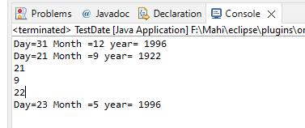Output -

**Q4 - Create a class Book with data members as bname,id,author,price. Write getters and setters for all the data members. Also add the display function. Create Default and Parameterized constructors. Create the object of this class in main method and invoke all the methods in that class.**

Ans - **package** day4and5and6;

**public** **class** Book {

**private** String bname;

**private** **int** id;

**private** String author;

**private** **int** price;

**public** Book() {

bname = "Basic Java";

id = 1234;

author = "PK Jadhav";

price = 999;

}

**public** Book(String bname, **int** id, String author, **int** price) {

**this**.bname = bname;

**this**.id = id;

**this**.author = author;

**this**.price = price;

}

**public** String getBname() {

**return** **this**.bname;

}

**public** **int** getId() {

**return** **this**.id;

}

**public** String getAuthor() {

**return** **this**.author;

}

**public** **int** getPrice() {

**return** **this**.price;

}

**public** **void** setName(String name) {

**this**.bname = name;

}

**public** **void** setAuthor(String author) {

**this**.author = author;

}

**public** **void** setId(**int** id) {

**this**.id = id;

}

**public** **void** setPrice(**int** price) {

**this**.price = price;

}

**public** **void** display() {

System.out.println(

"Book-Name: " + bname + "\nAuthor Name: " + author + "\nBook-Id: " + id + "\nPrice: " + price + "\n");

}

}

**package** day4and5and6;

**public** **class** TestBook {

**public** **static** **void** main(String[] args) {

Book b2 = **new** Book("Lets c", 150, "Kanetkar", 1999);

b2.setAuthor("Ram");

b2.getAuthor();

b2.display();

}

}

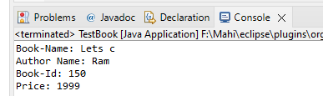Output

**Q5 - Create a class Point with data members as x,y. Create Default and Parameterized constructors. Write getters and setters for all the data members. Also add the display function. Create the object of this class in main method and invoke all the methods in that class.**

**Ans – package** day4and5and6;

**public** **class** Point {

**private** **int** x;

**private** **int** y;

**public** Point() {

x = 0;

y = 0;

System.out.println("-----default contr-----");

}

**public** Point(**int** x, **int** y) {

**this**.x = x;

**this**.y = y;

System.out.println("-------Paramterised contr--------");

}

**public** **int** getPointX() {

**return** **this**.x;

}

**public** **int** getPointY() {

**return** **this**.y;

}

**public** **void** setPointX(**int** x) {

**this**.x = x;

}

**public** **void** setPointY(**int** y) {

**this**.y = y;

}

**public** **void** display() {

System.out.println("Point X=" + x + "\nPoint Y=" + y);

}

}

**package** day4and5and6;

**public** **class** TestPoint {

**public** **static** **void** main(String[] args) {

Point P1 = **new** Point();

P1.display();

Point P2 = **new** Point(15, 15);

P2.display();

System.***out***.println("-----------------------------");

P1.setPointX(12);

P1.display();

System.***out***.println("-----------------------------");

P2.setPointY(16);

P2.display();

System.***out***.println("-----------------------------");

}

}

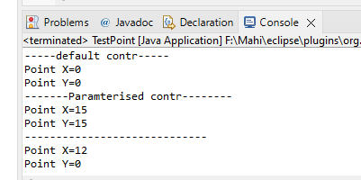Output

**Q6 - Create a class ComplexNumber with data members real, imaginary. Create Default and Parameterized constructors. Write getters and setters for all the data members. Also add the display function. Create the object of this class in main method and invoke all the methods in that class.**

Ans - **package** day4and5and6;

**public** **class** ComplexNumber {

**private** **float** real;

**private** **float** imaginary;

**public** ComplexNumber() {

real = 3.14f;

imaginary = -1.41f;

System.out.println("This is Default contr");

}

**public** ComplexNumber(**float** real, **float** imaginary) {

**this**.real = real;

**this**.imaginary = imaginary;

System.out.println("This is Parameterised contr");

}

**public** **void** setReal(**float** real) {

**this**.real = real;

}

**public** **void** setImaginary(**float** imaginary) {

**this**.imaginary = imaginary;

}

**public** **float** getReal() {

**return** real;

}

**public** **float** getImaginary() {

**return** imaginary;

}

**public** **void** display() {

System.out.println("Real Number is:" + real + "\nImaginary Number is" + imaginary);

}

}

**package** day4and5and6;

**public** **class** TestComplexNumber {

**public** **static** **void** main(String[] args) {

ComplexNumber CN1 = **new** ComplexNumber();

CN1.display();

System.***out***.println("--------------------------------------");

ComplexNumber CN2 = **new** ComplexNumber(15.45f, -6.532f);

CN2.display();

System.***out***.println("--------------------------------------");

CN1.setReal(5.5f);

CN1.display();

System.***out***.println("--------------------------------------");

CN2.setImaginary(-9.655f);

CN2.display();

System.***out***.println("--------------------------------------");

}

}

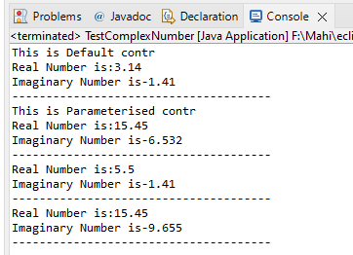Output –

**Q7 - create BankAccount aaplication for operations like withdraw ,deposite and ShowBalance Create menu drive program for bank operations.**

Ans –

**package** day4and5and6;

**public** **class** BankAccountBL {

**public** **int** accountnumber;

**private** String name;

**private** **int** balance;

BankAccountBL() {

accountnumber = 1111;

name = "SBIAccount";

balance = 5000;

}

BankAccountBL(**int** accountnumber, String name, **int** balance) {

**this**.accountnumber = accountnumber;

**this**.name = name;

**this**.balance = balance;

}

**public** **void** displayBal() {

System.out.println("Current Balance of Account is:" + balance);

}

**public** **void** displayDetails() {

System.out.println("Name:" + name + "\nAccount Number:" + accountnumber + "\nBalance" + balance);

}

**public** **void** deposit(**int** depo) {

balance = balance + depo;

}

**public** **void** withdraw(**int** wd) {

balance = balance - wd;

}

}

**package** day4and5and6;

**import** java.util.Scanner;

**public** **class** BankAccountTest {

**public** **static** **void** main(String[] args) {

Scanner in = **new** Scanner(System.***in***);

BankAccountBL A1 = **new** BankAccountBL();

**int** choice;

System.***out***.println("---Menu--- \n1:Deposit 2:Withdraw 3:Display Balance 4:Display All Details 5:Exit");

**do** {

System.***out***.println("Enter the choice");

choice = in.nextInt();

**switch** (choice) {

**case** 1:

System.***out***.println("Enter the Amount want to deposit:");

A1.deposit(in.nextInt());

**break**;

**case** 2:

System.***out***.println("Enter the Amount want to withdraw:");

A1.withdraw(in.nextInt());

**case** 3:

A1.displayBal();

**break**;

**case** 4:

A1.displayDetails();

**break**;

**case** 5:

System.***out***.println("** Thank You for banking with us **");

**break**;

**default**:

System.***out***.println("Invalid Entry");

}

} **while** (choice != 5);

in.close();

}

}

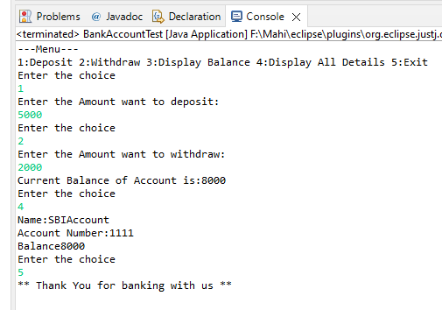

Output –

**Q8 - Create array of BankAccount class and store 5 objects....create menu driven application for same.....ex. show all account names ,balance,email.**

Ans - **package** day4and5and6;

**public** **class** BankAccountBLArray {

**private** **int** accountnumber;

**private** String name;

**private** **int** balance;

**private** **static** **int** counter;

**private** **static** String bankname;

**private** String email;

**private** String city;

BankAccountBLArray() {

}

BankAccountBLArray(String name, **int** balance, String city, String email) {

**this**.accountnumber = counter;

**this**.name = name;

**this**.balance = balance;

**this**.city = city;

**this**.email = email;

counter++;

}

**static** {

counter = 1001;

bankname = "SBI BANK";

}

**public** **void** displayBal() {

System.out.println("Current Balance of Account is:" + balance);

}

**public** **void** displayDetails() {

System.out.print("\nBank Name : " + bankname + "\nName : " + name + "\nAccount Number : " + accountnumber

+ "\nBalance : " + balance + "\nCity :" + city + "\nEmail :" + email);

}

**public** **void** deposit(**int** depo) {

balance = balance + depo;

}

**public** **void** withdraw(**int** wd) {

balance = balance - wd;

}

**public** **void** setName(String name) {

**this**.name = name;

}

**public** **void** setCity(String city) {

**this**.city = city;

}

**public** **void** setEmail(String email) {

**this**.email = email;

}

**public** **int** getAcc() {

**return** **this**.accountnumber;

}

**public** String getName() {

**return** **this**.name;

}

}

**package** day4and5and6;

**import** java.util.Scanner;

**public** **class** BankAccountTestArray {

**public** **static** **void** main(String[] args) {

Scanner in = **new** Scanner(System.***in***);

System.***out***.println("How Many Account You want to create:");

**int** totalA = in.nextInt();

BankAccountBLArray[] B = **new** BankAccountBLArray[totalA];

System.***out***.println("Enter the Details = Name , Balance , Email , City");

**for** (**int** i = 0; i < B.length; i++) {

B[i] = **new** BankAccountBLArray(in.next(), in.nextInt(), in.next(), in.next());

}

System.***out***.println("First Account Number is:" + B[0].getAcc());

**int** choice;

**do** {

System.***out***.println("\nEnter the choice for Main Menu :");

System.***out***.println("**** Menu ****");

System.***out***.println(

"1:Deposit 2:WithDraw 3:Display Balance 4:Display All Details 5:Money Transfer 6:Update Detail 7:Exit");

choice = in.nextInt();

**switch** (choice) {

**case** 1:

System.***out***.println("Enter the Account number to deposit");

**int** acc = in.nextInt();

**int** count = 0;

**int** index = 0;

**for** (**int** i = 0; i < B.length; i++) {

**int** adf = B[i].getAcc();

**if** (acc == adf) {

count++;

index = i;

}

}

**if** (count == 1) {

System.***out***.println("Enter the Amount");

B[index].deposit(in.nextInt());

B[index].displayBal();

} **else** {

System.***out***.println("Account not found ");

}

**break**;

**case** 2:

System.***out***.println("Enter the Account number to withdraw");

acc = in.nextInt();

count = 0;

index = 0;

**for** (**int** i = 0; i < B.length; i++) {

**if** (acc == B[i].getAcc()) {

count++;

index = i;

}

}

**if** (count == 1) {

System.***out***.println("Enter the Amount");

B[index].withdraw(in.nextInt());

B[index].displayBal();

} **else** {

System.***out***.println("Account not found ");

}

**break**;

**case** 3:

System.***out***.println("Enter the Account to display Balance");

acc = in.nextInt();

count = 0;

index = 0;

**for** (**int** i = 0; i < B.length; i++) {

**if** (acc == B[i].getAcc()) {

count++;

index = i;

}

}

**if** (count == 1) {

B[index].displayBal();

;

} **else** {

System.***out***.println("Account not found ");

}

**break**;

**case** 4:

System.***out***.println("Enter the Account to display All details");

acc = in.nextInt();

count = 0;

index = 0;

**for** (**int** i = 0; i < B.length; i++) {

**if** (acc == B[i].getAcc()) {

count++;

index = i;

}

}

**if** (count == 1) {

B[index].displayDetails();

;

} **else** {

System.***out***.println("Account not found ");

}

**break**;

**case** 5:

System.***out***.println("Enter the Account numbber from you want to send Money:");

**int** sender = in.nextInt();

count = 0;

**int** senderindex = 0;

**int** receiverindex = 0;

**for** (**int** i = 0; i < B.length; i++) {

**if** (sender == B[i].getAcc()) {

count++;

senderindex = i;

}

}

**if** (count == 1) {

System.***out***.println("Enter the account number to send money");

**int** receiver = in.nextInt();

**for** (**int** i = 0; i < B.length; i++) {

**if** (receiver == B[i].getAcc()) {

count++;

receiverindex = i;

}

}

**if** (count == 2) {

System.***out***.println("Enter Money you want to tranfer:");

**int** money = in.nextInt();

B[senderindex].withdraw(money);

B[receiverindex].deposit(money);

} **else** {

System.***out***.println("Receiver account not found");

}

} **else** {

System.***out***.println("Sender Account Not found");

}

**break**;

**case** 6:

System.***out***.println("Enter the Account Number to Update Details:");

**int** accNoUP = in.nextInt();

count = 0;

index = 0;

**for** (**int** i = 0; i < B.length; i++) {

**if** (accNoUP == B[i].getAcc()) {

count++;

index = i;

}

}

**if** (count == 1) {

System.***out***.println("Enter the Choice for updating Info. 1:Name 2:Email 3:city ");

**int** ch = in.nextInt();

**switch** (ch) {

**case** 1:

System.***out***.println("Enter New Name:");

B[index].setName(in.next());

**break**;

**case** 2:

System.***out***.println("Enter New Email :");

B[index].setEmail(in.next());

**break**;

**case** 3:

System.***out***.println("Enter New City :");

B[index].setCity(in.next());

**break**;

**default**:

System.***out***.println("Invalid Entry");

}

} **else** {

System.***out***.println("Account not found ");

}

**break**;

**case** 7:

System.***out***.println("Thank You for banking with Us");

**break**;

**default**:

System.***out***.println("Invalid Entry");

}

} **while** (choice != 7);

in.close();

}

}

Output

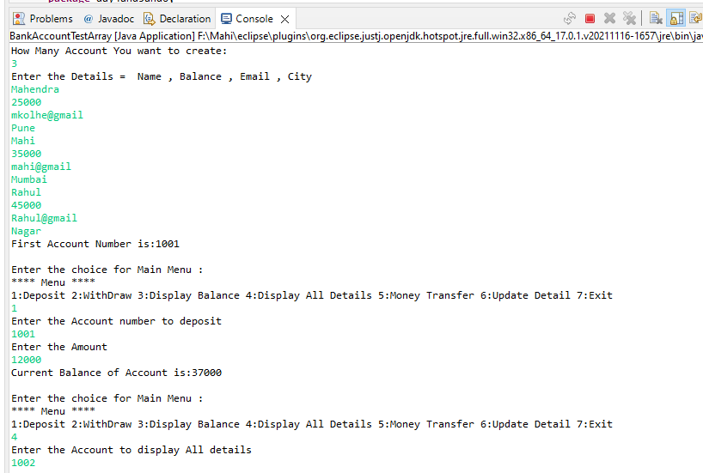

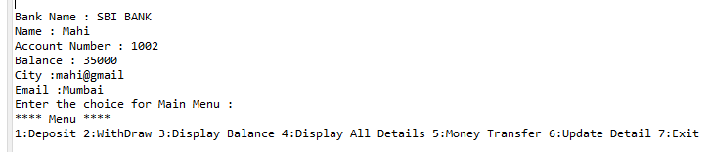

**COP Assignment 4**

**Q1 - Create Date class with members day, month, year. Write no argument and parameterised constructor. Create two object s and initialize them using no argument and parameterised constructor respectively. Print date using display function.**

Ans - **package** day7;

**public** **class** Date {

**private** **int** dd;

**private** **int** mm;

**private** **int** yy;

**public** Date() {

}

**public** Date(**int** dd, **int** mm, **int** yy) {

**this**.dd = dd;

**this**.mm = mm;

**this**.yy = yy;

}

**public** **void** display() {

System.out.println("Date:" + dd + "-" + mm + "-" + yy);

}

**public** **void** acceptInfo(**int** d, **int** m, **int** y) {

**this**.dd = d;

**this**.mm = m;

**this**.yy = y;

}

}

**package** day7;

**public** **class** DateTest {

**public** **static** **void** main(String[] args) {

Date D1 = **new** Date();

D1.display();

Date D2 = **new** Date(23, 05, 1996);

D2.display();

}

}

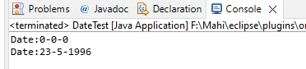Output –

**Q2 - Create Employee class with members id(int),name(string),dob(Date).Use above created Date class. Write default and parameterised constructor in Employee Class.Write accept() function to accept information and display() to display emp information.**

Ans - **package** day7;

**import** java.util.Scanner;

**public** **class** Employee {

**private** **int** id;

**private** String name;

Date d = **new** Date();

Scanner sc = **new** Scanner(System.***in***);

**public** Employee() {

}

**public** Employee(**int** id, String name, **int** dd, **int** mm, **int** yy) {

**this**.id = id;

**this**.name = name;

}

**public** **void** acceptInfo(**int** id, String name) {

System.***out***.println("Enter Date of Birth of Emp");

**int** dd = sc.nextInt();

**int** mm = sc.nextInt();

**int** yy = sc.nextInt();

d.acceptInfo(dd, mm, yy);

**this**.name = name;

**this**.id = id;

}

**public** **void** display() {

System.***out***.println("ID : " + id + "\nName : " + name);

d.display();

}

}

**package** day7;

**import** java.util.Scanner;

**public** **class** EmployeeTest {

**public** **static** **void** main(String[] args) {

Scanner in = **new** Scanner(System.***in***);

// Employee E1 = new Employee();// Default

Employee E2 = **new** Employee();// Parameterised

System.***out***.println("Enter ID And name ");

**int** id = in.nextInt();

String name = in.next();

E2.acceptInfo(id, name);

E2.display();

in.close();

}

}

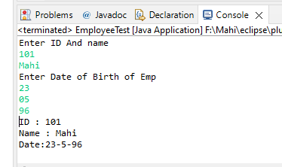

Output –

**Q3 - Consider that payroll software needs to be developed for computerization of**

**operations of an ABC organization. The organization has employees.**

**3.1. Construct a class Employee with following members using private access specifies:**

**3.2. Write methods to display the details of an employee and calculate the gross**

**Ans - package** day7;

**public** **class** Payroll {

**private** **int** empId;

**private** String empName;

**private** **double** baseSal;

**private** **double** hra;

**private** **int** Medical;

**private** **double** pf;

**private** **double** pt = 200;

**private** **double** grosSal;

**private** **double** netSal;

**public** Payroll() {

}

**public** Payroll(String empName, **int** empId, **double** baseSal) {

**this**.empId = empId;

**this**.empName = empName;

**this**.baseSal = baseSal;

}

**public** **void** display() {

hra = 0.5 * baseSal;

Medical = 1000;

pf = 0.12 * baseSal;

pt = 200;

grosSal = (baseSal + hra + Medical);

netSal = (grosSal - (pt + pf));

System.***out***.println(

"Name: " + empName + "\nId: " + empId + "\nGross Salary: " + grosSal + "\nNet salary: " + netSal);

}

}

**package** day7;

**import** java.util.Scanner;

**public** **class** PayrollTester {

**public** **static** **void** main(String[] args) {

Scanner in = **new** Scanner(System.***in***);

System.***out***.println("Enter the Following Details of employee");

System.***out***.println("Name , Employee ID , Basic Salary");

String name = in.next();

**int** id = in.nextInt();

**double** salary = in.nextDouble();

Payroll E1 = **new** Payroll(name, id, salary);

E1.display();

in.close();

}

}

Output -

